Supplementary materials (2)

These supplementary materials provide additional details of data processing as used for the paper published in Plant and Soil.

Towards a better understanding of soil nutrient dynamics and P and K uptake
Antonius G.T. Schut¹, W. Reymann^{1,2}.
¹Wageningen University and Research Centre, Plant Production Systems group, Department of Plant Sciences, Wageningen, the Netherlands. ²FIBL, Nutrient Management & Symbiosis group, Department of Soil Sciences, Frick, Switzerland.

Introduction
The dataset from the Broadbalk experiment has been used by many and has been described in detail elsewhere. The original experiment on the Broadbalk field included wheat only with sections where monoculture and different fallow treatments where compared. In 1968, 10 new sections were created replacing the old sections. Wheat monoculture was continued in sections 0, 1 and 9, sections 6 and 8 included wheat with fallow years. Sections 3, 5 and 6 had initially the same rotation with wheat and fallow, but in a later stage, crop rotations where established on sections 3 and 5.
In sections 2, 4 and 7 crop rotations where established. The experiment includes sections to separate crop types and rotations and strips with treatments cutting across these sections. Experimental data on crop yields and nutrient contents were provided in separate documents. Further, details of treatments, amounts of mineral fertilizer and manure applied are all provided in separate documents and needed substantial processing.
The first objective was to compile a full data frame including estimates of missing values where possible and including all details in one document. Fertilizer regimes changed in 1986, 2001, 2002 and 2007. For each period, a factor was added to enable an analyses of uptakes and recovery over the full time period, accounting for these regime changes. Estimates of long-term nutrient recovery of N, P and K from mineral fertilizer and FYM were added in separate columns. The second objective was to remove annual variability, and estimate offtakes and recovery values for each treatment using predictions of linear regression models accounting for all known sources of variation.

Methods
First, N, P and K offtakes were computed for grain and straw separately for cereals and beans. Estimates for wheat straw N, P and K offtakes were made to replace missing data in sections 2, 4 and 7. Finally, offtakes were computed by summing the offtakes in grain and straw, both crop components were removed from the field. For potato, only uptakes in potato tubers were known, straw remained on the field.
Objective 1. The following linear regression models were fitted to the data to estimate straw N offtake:
$$Straw N_{off.}= {Grain N}_{off.}+{Grain P}_{off.}+{Grain K}_{off.}+Yield+N_{appl.}+P_{appl.}+K_{appl.}+year ×{(N}_{appl.}+Treatment)$$
All variables are in kg ha⁻¹. The same equations were fitted to estimate Straw P and K offtake. First, these models were calibrated on data from sections 2 and 7 only. Predictions were made for section 4 and compared with measured data to evaluate accuracy of these models. As the final step, the models were trained on all available data from sections 2, 4 and 7 and used to predict missing values.
And N recovery over the course of the experiment:
$$N_{rec.}= fert. regime+crop×year +section$$
This was also done for P and K. Similarly, for nutrients from FYM and combinations of FYM with mineral fertilizer (FYM-NPK) recovery was determined. So, for N alone, three different recovery values can be determined. See table 3 for possible combinations.

For objective 2, the following equation was fitted to estimate the total N offtake (kg/ha):
$$N_{off.}= fert. regime×treatment+crop×\left(year+treatment\right)+section ×year$$

The following problems arose when analysing the data.
- Straw yields and associated nutrient contents where not always measured in sections 2, 4 and 7.
- There were no P and K contents measured between 1976-1985.
- Errors in the data. For 2017, plot numbers have been mixed up and not useful for analysis. For 2004, Na contents contained minor errors due to problems with a blank in the laboratory. These should be excluded.
For 2014, problems were found for wheat straw nutrient contents. Corrected values were shared by Dr Glendining and updated records have been used.

Results
The fitted models explained 68.3%, 60.9% and 68.3% of the variation in the calibration dataset. The root mean squared errors in the test dataset (section 4 data) were slightly lower than the errors in the calibration dataset (Table 1).

Table 1. Root means squared errors for N, P and K offtakes in straw.
 |  |  |  | RMSE, kg/ha
 |  | N |  | P |  | K
Calibration |  | 7.2 |  | 1.31 |  | 18.0
Section 4 test |  | 7.4 |  | 1.05 |  | 14.5

The uncertainty in the predicted nutrient offtakes with straw had a relatively small influence on the estimates of offtake (Figure 1).
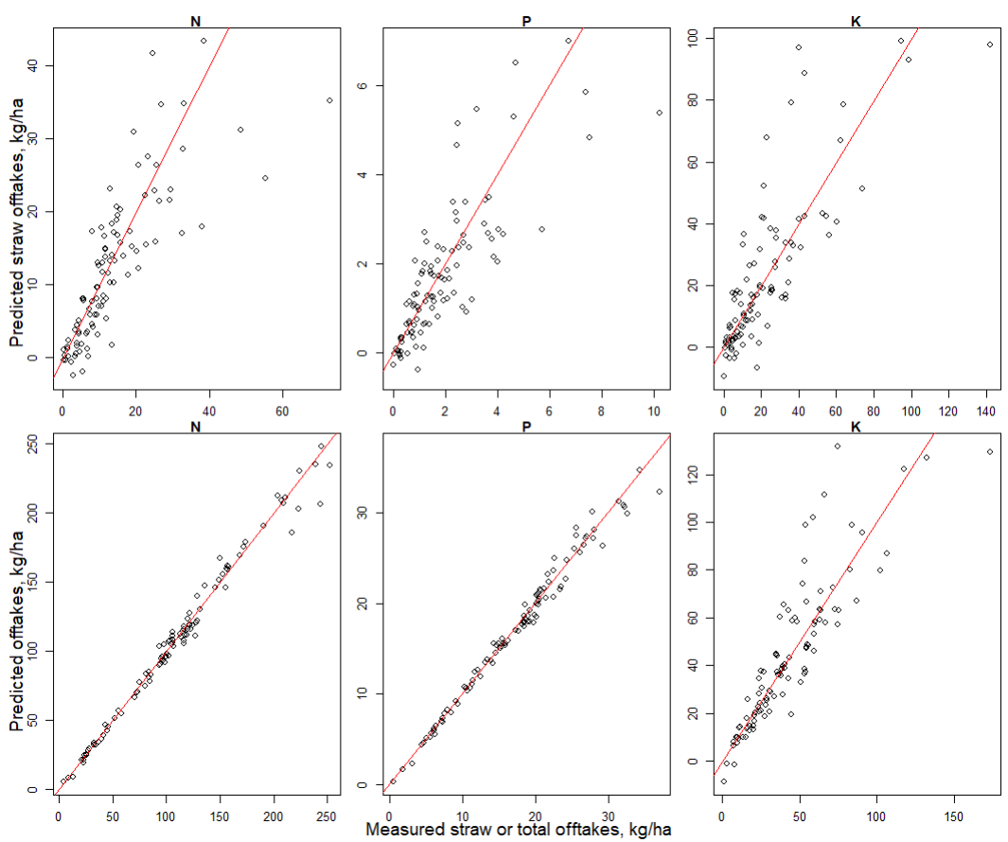

Figure 1. Comparison between measured and predicted values for offtakes in straw and calculated total offtakes using these predicted values for section 4.

The model to estimate the dynamic offtakes explained a proportion of 0.78-0.84 of the variation (Table 2) with reasonably low RMSE values. The dynamics in recovery were also captured well, although R2 values were a little lower. The RMSE values of the mineral sources were larger for N and K, but smaller for P when compared to FYM.

Table 2. The R² value indicating the variation explained and the root mean squared error (RMSE) for N, P and K offtakes including grain and straw.
 |  | R² |  | RMSE (kg offtake ha⁻¹)
N |  | 0.83 |  | 22.2
P |  | 0.84 |  | 3.4
K |  | 0.78 |  | 23.0

Table 3. The R² value indicating the variation explained and the root mean squared error (RMSE) for N, P and K recovery. The treatment included N, P and K as mineral, FYM or as combination of mineral and manure. To compute and evaluate nutrient recovery, separate reference treatments were used.
Recovery | Treatment | Reference |  | R² |  | RMSE (kg uptake kg⁻¹ applied)
N | N2PKMg | PKMg |  | 0.76 |  | 0.16
P | N5PKMg | N / NKMg |  | 0.82 |  | 0.07
K | N5PKMg | NP |  | 0.74 |  | 0.28
FYMN | FYM | PKMg |  | 0.68 |  | 0.08
FYMP | FYM | N |  | 0.56 |  | 0.11
FYMK | FYM | NP |  | 0.60 |  | 0.10
N-FYM | FYM+NPK | FYM |  | 0.48 |  | 0.13
P-FYM | FYM+NPK | FYM |  | 0.57 |  | 0.06
K-FYM | FYM+NPK | FYM |  | 0.52 |  | 0.19

